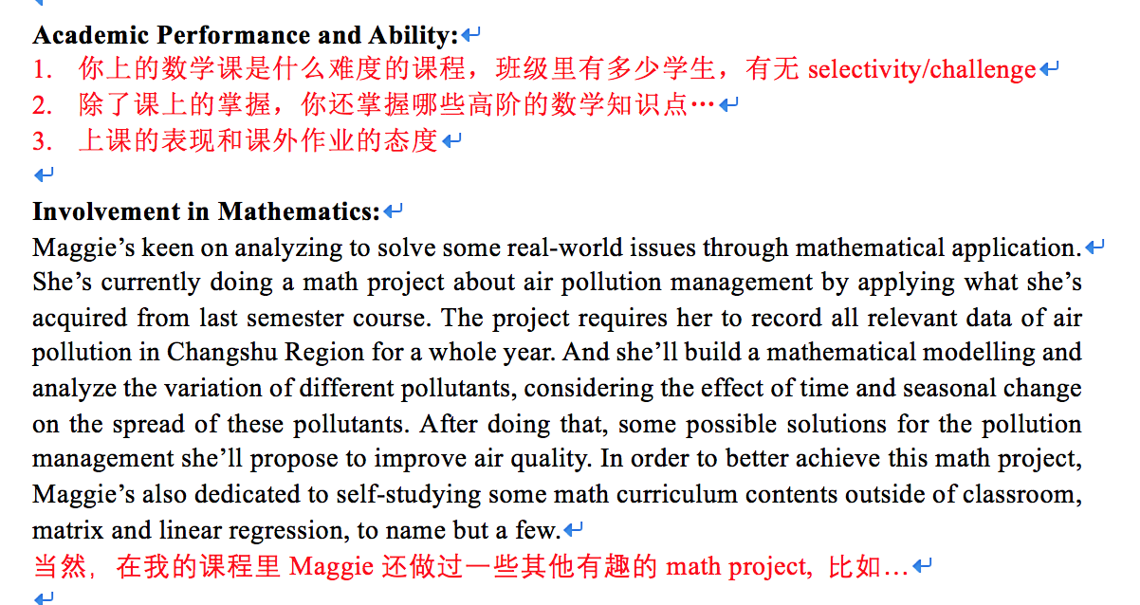

1. All the students in this course are from local school grade 10, which is the most the challenging one in pre-IBDP math courses, as the students should have a solid foundation for math and some basic knowledge about high school mathematics. There are 11 students in total. Maggie is the only one from grade 9 in the whole class, but she manages to catch up with her classmates and even perform better than most of them.
2. Apart from the knowledge we learn in this course, Maggie also keeps self-studying advanced high school knowledge, including the properties and applications of exponential, logarithmic & power function, solid and analytical geometry, trigonometry, the properties and operations of vectors, sequence and series, inequalities, conic sections, the concept and application of derivative, the operations of complex numbers, as well as permutations and combinations.
3. Maggie takes an active part in class and shows great passion for math studying. She is engaged in group discussions and group projects. She never fails to complete her homework with every effort and is able to present her ideas clearly in her works.

For instance, last semester Maggie did a math project on the investigation of the efficiency of different studying approaches by applying her learning in statistics and probabilities in class. She did an experiment in a primary school and collected three sets of data with different levels of practice intensity of math problems. She then analyzed the data by employing statistical approaches like hypothesis testing to determine the significance of her results and came to a convincing conclusion.